15.56: (a ) The wave travels a horizontal distance d in a time

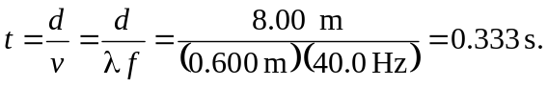

(b) A point on the string will travel a vertical distance of 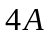 each cycle. Although the transverse velocity 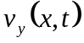 is not constant, a distance of 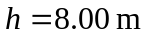 corresponds to a whole number of cycles, so the amount of time is

(c ) The answer for (a ) is independent of amplitude. For (b), the time is halved if the amplitude is doubled.

